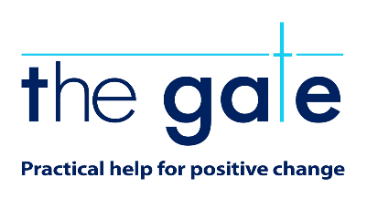

Application form

Application for ‘Shop Assistant’ 18 hours at The Gate Charity Shop, 69 Mill Street Alloa, FK10 1DX.

Your details

Name:

Address:

Postcode:

Phone:

Email:

Education and training
Please give details:

Qualifications
Please give details:

Employment history

Your current or most recent employer

Name of employer:

Address:

Postcode:

Job title:

Length of time with employer:

Reason for leaving:

Duties:

Previous employers
Please tell us about other jobs you have done and about the skills you used or learned in those jobs.

Supporting statement
Please tell us why you applied for this job and why you think you are the best person for the job.

Interview arrangements and availability
If you have a disability, please tell us if there are any reasonable adjustments we can make to help you in your application or with our recruitment process.

Are there any dates when you will not be available for interview?

When can you start working for us?

Right to work in the UK
Do you need a work permit to work in the UK? Yes / No

References
Please give the names and contact details of 2 people who we can ask to give you a reference. We may ask them before an employment offer is made. We will not ask your current employer until we get your permission.

Referee 1

Referee 2

Declaration
I confirm that to the best of my knowledge the information I have provided on this form is correct and I accept that providing deliberately false information could result in my dismissal.

Name:

Signature:

Date:

Please return: FAO – Jilly Guild, Chief Officer, The Gate Charity, 2 Ludgate Alloa FK10 2DR or email to jilly@the-gate-charity.org

